Reliability of Predictions
The bootstrapping analyses and RMSE calculations provide confidence measures for the findings:
1) The bootstrapped PM10 mean for NYC shows a tight distribution, indicating statistical reliability in the mean estimate.
2) Boston’s bootstrapped NO2 mean similarly shows good consistency.
3) Chicago’s bootstrapped PM2.5 mean shows a wider distribution, reflecting the higher variability in the data.
The RMSE vs. sample size plots show that prediction errors stabilize as sample sizes increase, with NYC’s plot showing stabilization around 3000–4000 samples. This indicates that the dataset size is sufficient for reliable analysis, though Chicago’s higher variability suggests more caution in interpreting those results.
Bootstrapped Distributions and RMSE Plot: 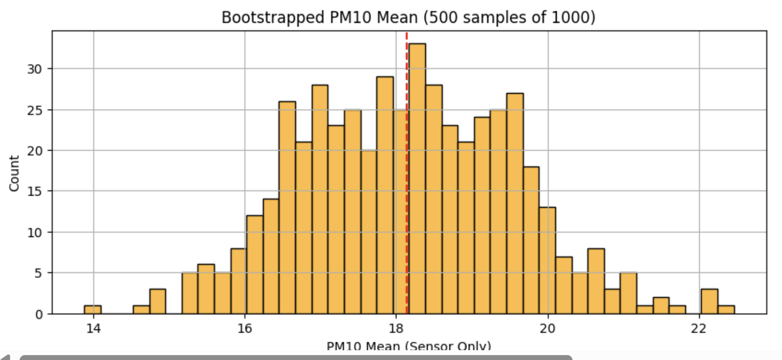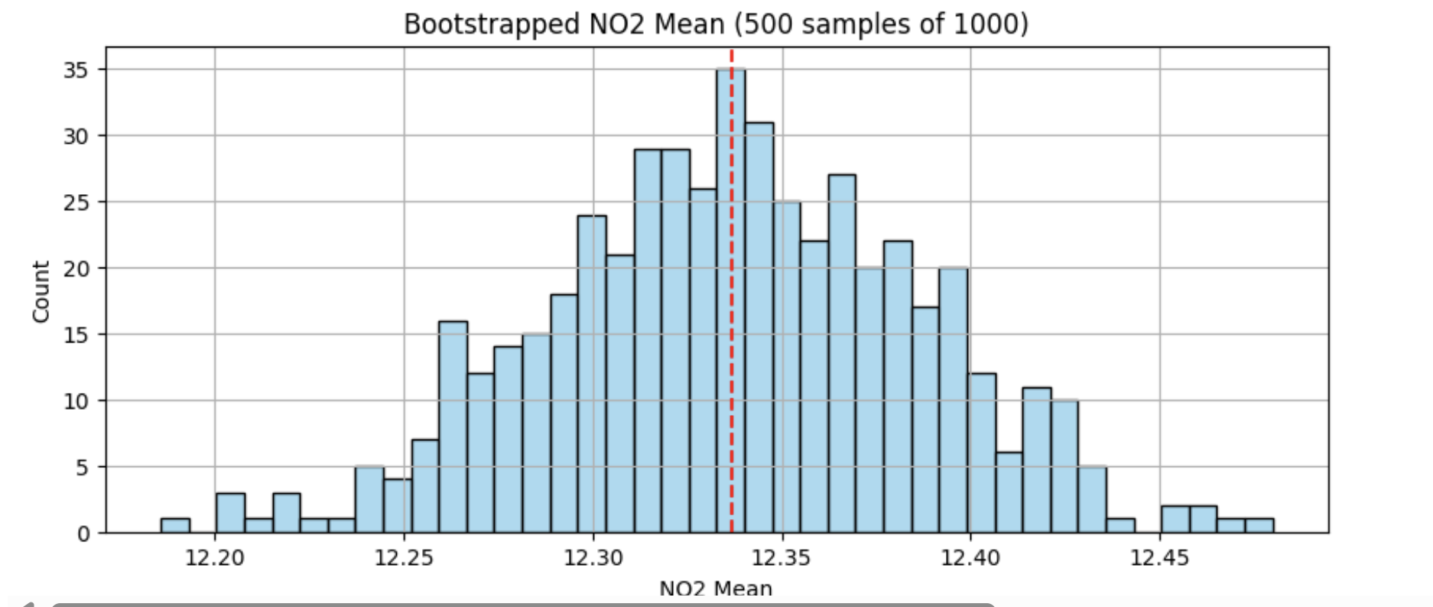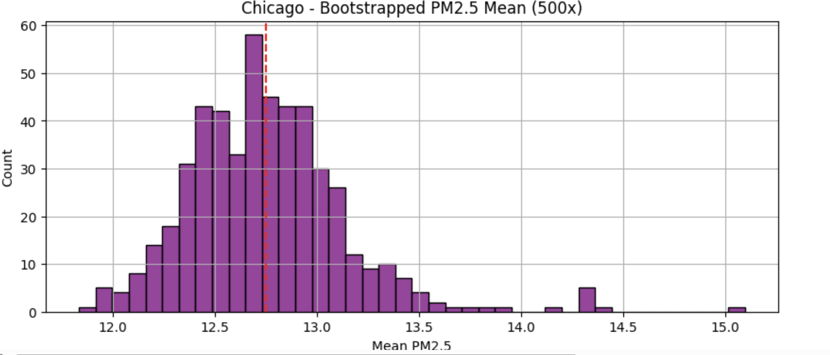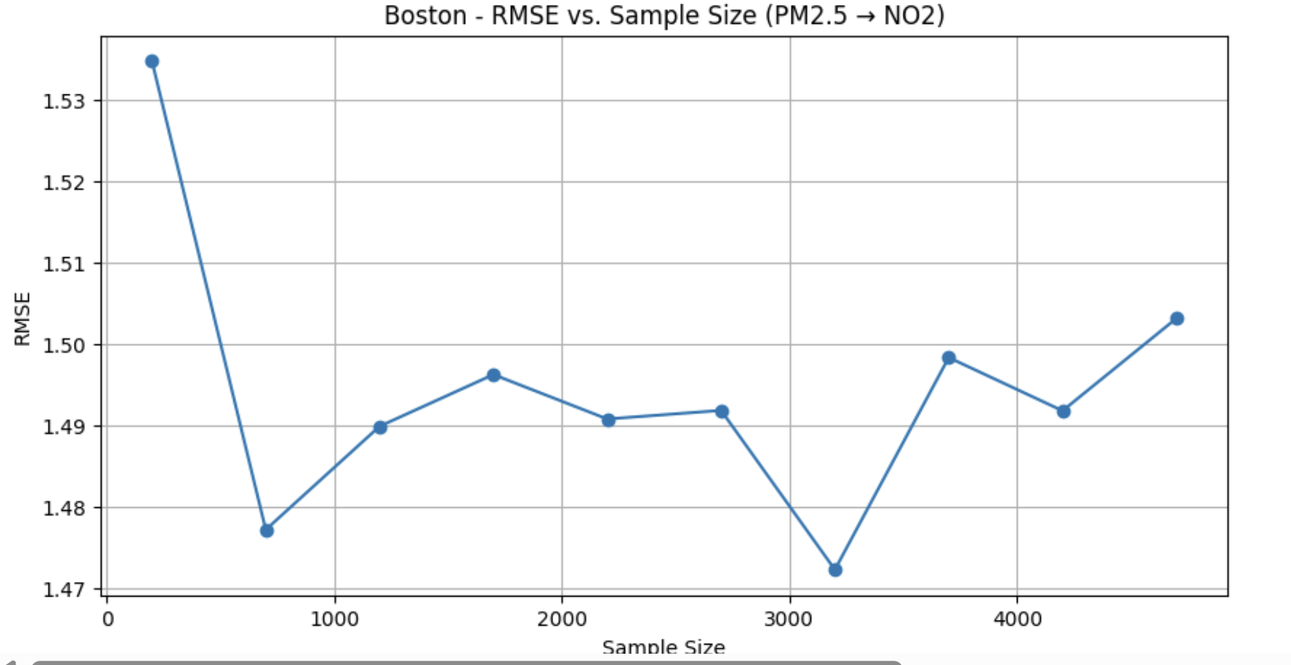

H. The Role of GIS in Accurate Comparisons
H3 geospatial indexing was crucial for making fair comparisons across these diverse urban environments. Our work demonstrates how H3 enables:
1) Consistent spatial aggregation across different city structures.
2) Identification of pollution hotspots at equivalent spatial scales.
3) Integration of point measurements into comparable spatial units.
4) Clustering of spatially similar areas across different cities.
Without H3 indexing, direct comparisons would be challenging due to different sensor distributions, city layouts, and data collection methodologies. The H3 system provides a standardized spatial framework that enables fair cross-city comparison by ensuring that analyses are conducted on equivalent spatial units regardless of underlying urban structure.
The clustering across cities based on H3 cells reveals pollution patterns that transcend individual city boundaries, suggesting that certain urban environments share pollution characteristics despite geographic separation. 

